17.10.2019

Furkan Tokgöz

**Parallel Interleaving FFT Results**

In this report, I have included all the data, results and analysis of the test setup with parallel configuration. I have put the results with and without interleaving at the same graph so that it would be easier to compare.

Below you can see the FFT analysis result of total DC link voltage at low frequency. 100 Hz harmonic component is a result of phase unbalance of the modules whereas 300 Hz component is caused by 6-pulse rectifier.

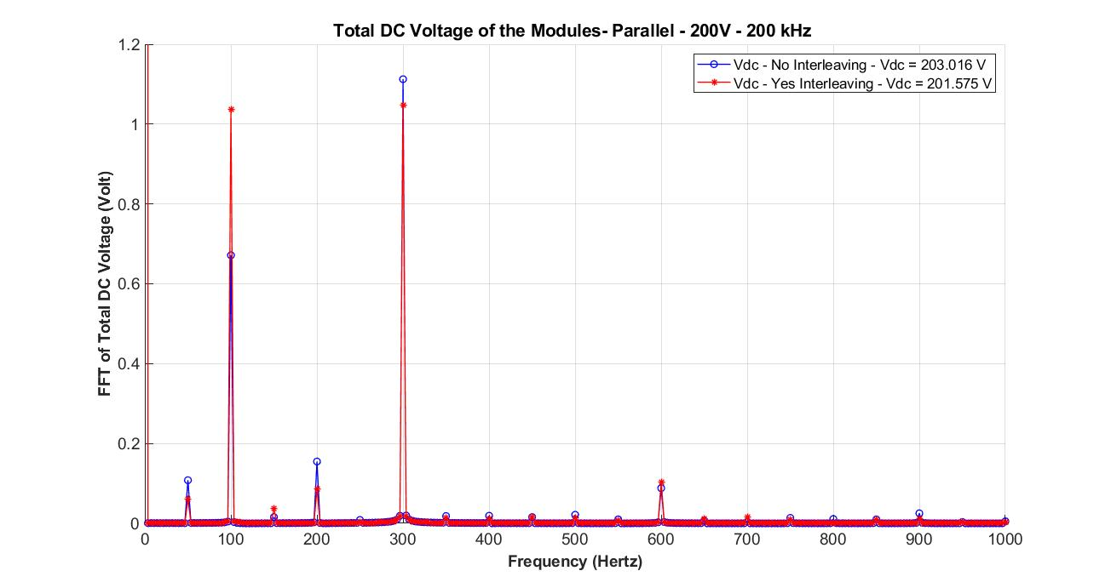

The result of high frequency FFT analysis can be seen below. We expect interleaving to diminish the high frequency harmonic components. However, it seems it not working as planned. It remains unclear why interleaving had no effect on high frequency components. It is noted as a topic to be worked on.

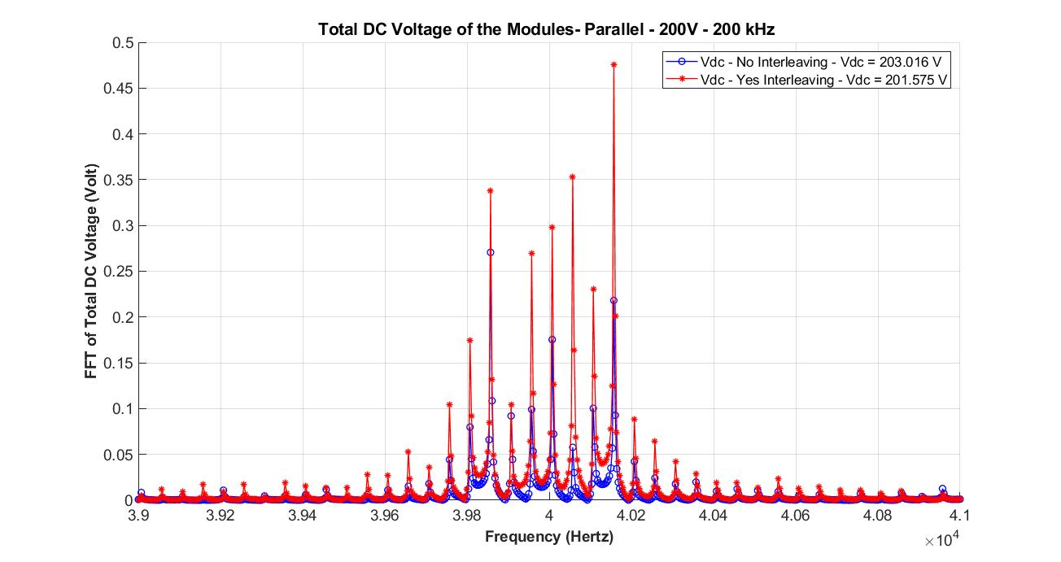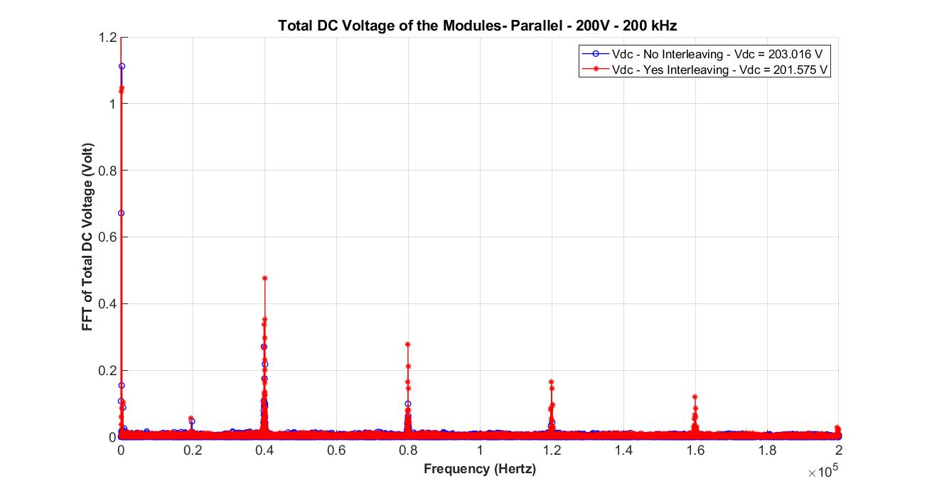 As, interleaving had not effect on 40 kHz component, the multiples of 40 kHz frequency had also harmonic components as can be seen below.

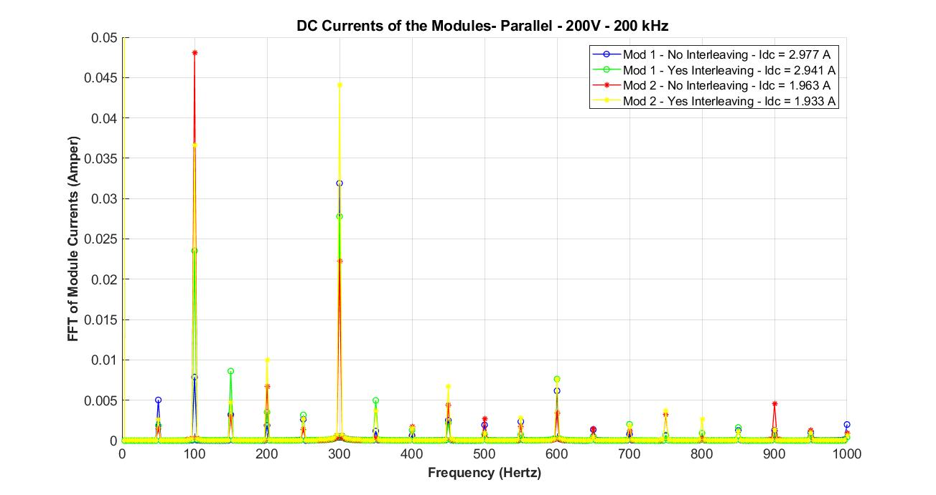 Next, I want to focus on DC currents of the module-1 and module-2. Low frequency FFT analysis does not present a clear understanding about low frequency harmonics. Since, the magnitude of these harmonics are very small, they can easily be polluted by the noises and measuring equipment.

The high frequency FFT analysis clearly shows us that interleaving has an adverse effect on 40 kHz component. In both of the modules, interleaving caused a higher level of harmonic. However, just looking at the magnitude of these harmonics might be deceiving because as we will see in the following pages, the summation of these components will cancel each other because of the phase difference between. So, we can say that interleaving improved the harmonic content in currents at high frequencies.

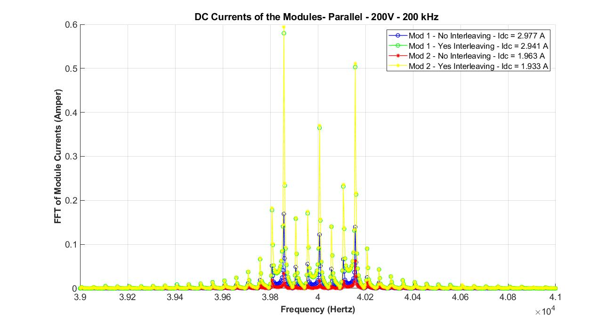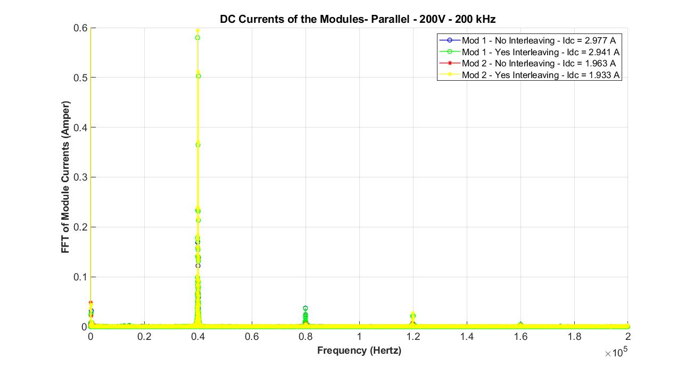 We can see that 40 kHz harmonic components is much more dominant that higher order harmonics.

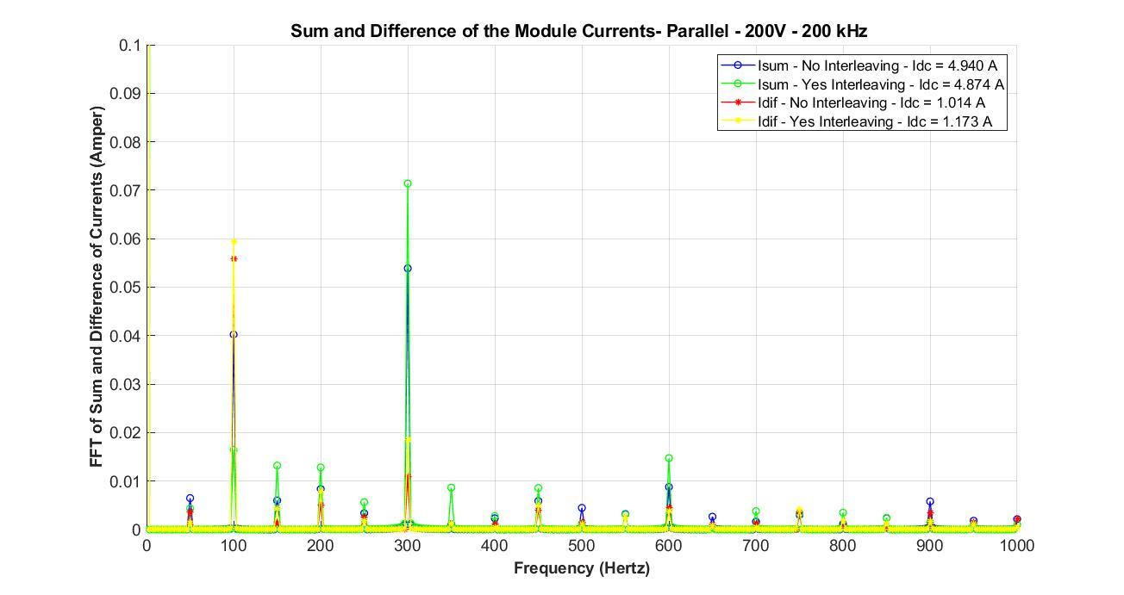 Next, summation and difference of the currents are investigated in FFT analysis. When we compare summation of the currents, we can see that interleaving improved the harmonic content at 100 Hz. However, we should take this information with a grain of salt since, the magnitude at 100 Hz is relatively small compared to the DC component of the current.

When we look at high frequency results, we can say that there is a very high circulating current at 40 kHz with interleaving although, this is not an unexpected result. As I have stated earlier, interleaving seems to be working since it cancels the high frequency harmonics at currents. In a series configuration, we have observed that the total high frequency DC link voltage ripples decreases with interleaving. In parallel configuration, however, total high frequency DC current ripple decreases. They are complementary of each other.

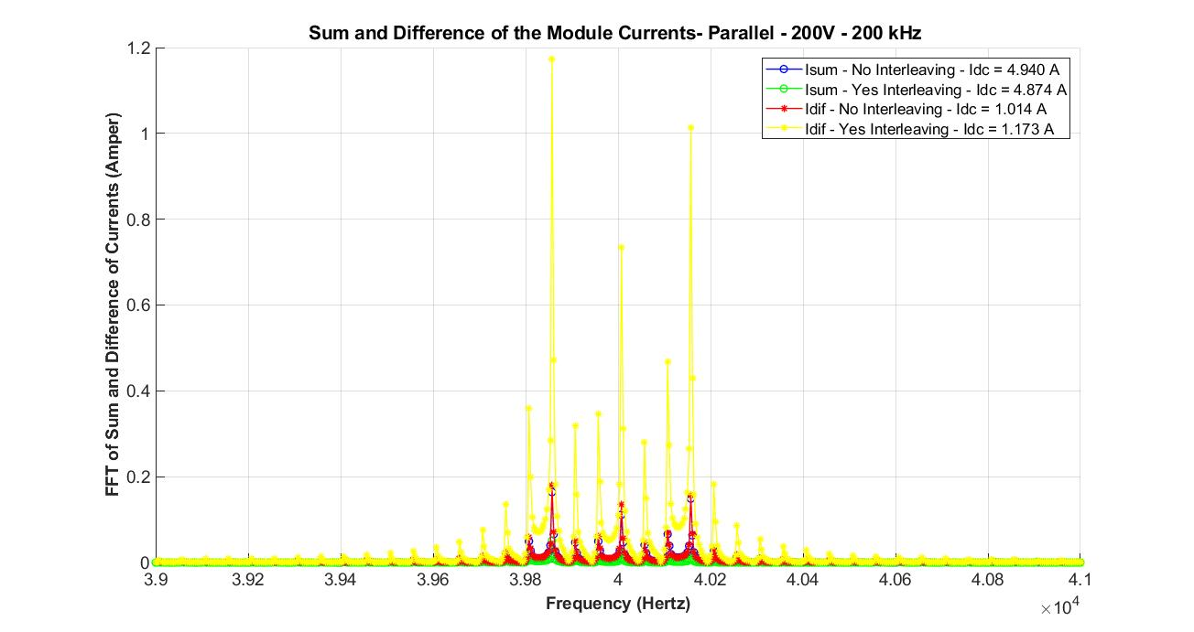

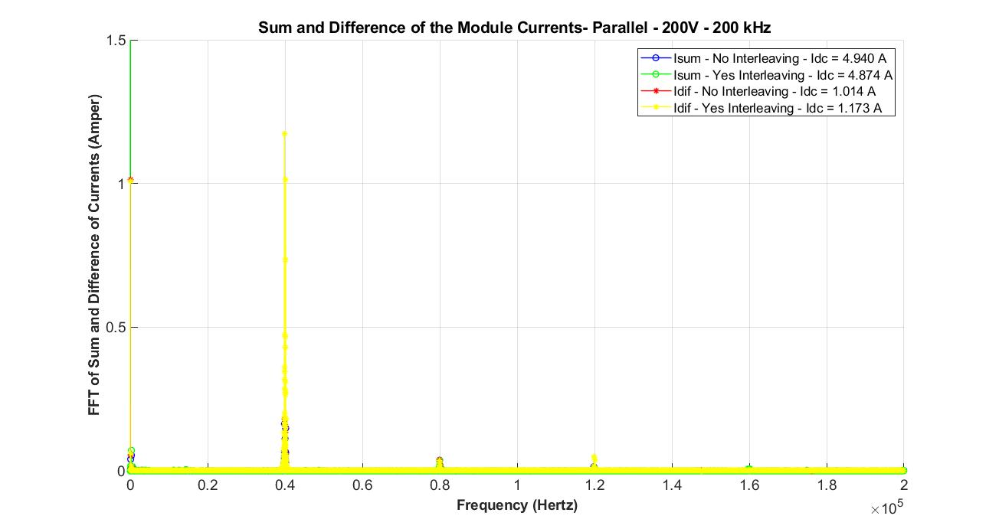At very high frequencies, there are no harmonic components left in the current waveforms.